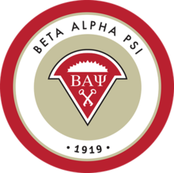
Spring 2021
Beta Alpha Psi
University of North Florida
Xi eta CHAPTER
CANDIDATE MANUAL

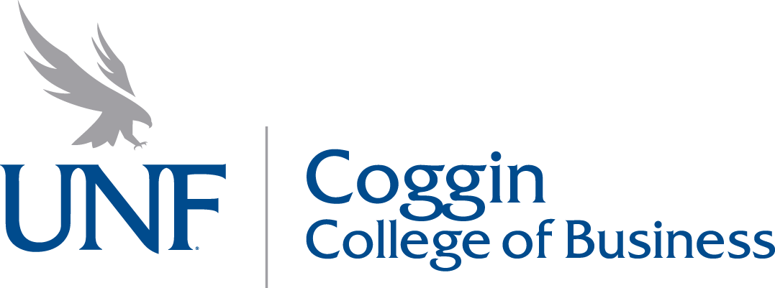

The following Candidate Manual was approved on January, 7 2021, in accordance with Article II, Section 4, Paragraph B of the Chapter Bylaws.
Table of Contents
Introduction 2
General Information 2
Becoming a Member 2
Dues 3
Attendance Requirements 3
Point System 4
Board Meetings 4
Spring 2021 Calendar 5
Chapter Communication 6
Chapter Board of Directors and Advisor 7

Introduction
As members of the UNF Chapter of Beta Alpha Psi, we want to thank you for considering becoming part of our organization. We believe you have taken a major step forward in your career and will do our best to welcome you as a candidate and future member. We hope your experience is everything you wish it to be and more!

General Information
Beta Alpha Psi is an honor organization that seeks to elevate students and professionals in their career. Since 1919, Beta Alpha Psi has added over 300 chapters and 300,000 members to its growing network. UNF’s Xi Eta Chapter was initiated on April 5th, 2019 as the 331st chapter with roughly 50 founding members. Beta Alpha Psi is well regarded in the accounting professional communities. The UNF chapter is highly supported within Jacksonville and the surrounding areas with 18 sponsoring firms, including the Big 4 and prominent regional and local firms.

The Chapter will hold its next induction ceremony on April 16th, 2021. All candidates that meet membership requirements in Spring 2021 will be inducted at the ceremony in the Fall 2021 semester (tentatively scheduled for November 30th, 2021) at our annual banquet.

Becoming a Member
Becoming a member of Beta Alpha Psi is a two-step process:
- First semester as a candidate. During this semester, candidates submit their application and candidate dues. Candidates are expected to meet specific attendance requirements at Beta Alpha Psi events (see “Attendance Requirements” section for additional details). Candidates who do not meet the academic and attendance requirements during the candidacy period will not be inducted as members to Beta Alpha Psi.
  - According to the Chapter Bylaws, a student may only remain a candidate for one (1) academic semester. If academic and attendance requirements are not met within the candidacy semester, the student will not be permitted to re-apply to the organization in future semesters. In addition, if you had conditions for your candidacy and did not meet these (e.g., you had to complete ACG 3103 (Intermediate Accounting) I with a “B” or better) and did not, you will not be permitted to reapply.

- Second semester through graduation as a Member in Good Standing. As a Member in Good Standing, members are expected to continue meeting all requirements for MGS.
  - Membership in Good Standing (MGS): Meet all BAP requirements as detailed in the Candidate Member manual, including timely payment of dues and attendance of BAP and BAP-promoted events as outlined in the “Attendance Requirements” section below.

Upon graduation, UNF BAP alumni members are encouraged to keep in touch with the Chapter and are invited to return as representatives for their firms at networking events.

Dues
Dues and applications for the Spring 2021 semester must be submitted online by 1/29 at 5pm.

The application is to be completed online and can be found on the UNF BAP website. To successfully submit your application, all required questions must be answered. If you have any questions regarding the application or payment, please reach out to Gibson Pardue at recruitment.unfbap@gmail.com.
Dues for the Candidate semester are $120 ($90 for students who received an A in Principles of Financial Accounting at UNF), which includes membership fee to the Beta Alpha Psi International and access to all UNF BAP exclusive events. Dues for Newly Initiated Members and MGS semesters are $50 per year or $30 per semester. We are only accepting payment through Venmo with the following link: @UNFBAP.
All dues for approved candidates are non-refundable per International Office policy. Candidate grades will be reviewed through our Faculty Advisor, Prof. Mark Leininger. Students who apply and turn in dues but who are not approved to become candidates for academic reasons will receive a refund. Please note that students accepted as candidates who fail to meet the attendance requirements outlined below or who fail to meet the academic requirements at any time during candidacy will not receive a refund.

Attendance Requirements
Candidates are required to attend at a minimum:
- One (1) Candidate Orientation
- Six (6) of the ten (10) Beta Alpha Psi network events (~60%)
- One (1) Coggin Career Week event
- The Initiation
- One (1) BAP Board Meeting
- Four (4) hours of Volunteering with BAP or Participate in one (1) BAP Volunteer Event (which is roughly three hours)*
- Earn five (5) additional points by attending or completing various other BAP, or BAP-promoted, activities (view “Point System” section below)
*Four hours of volunteering can be done through tutoring.
The schedule of events is below and can be accessed on our website www.unfbap.org and Perch Portal https://unf.campuslabs.com/engage/. Candidates and members must complete the Canvas attendance quiz at all meetings and socials to be counted as present for those events.

If you arrive at meetings 15 minutes late or leave 15 minutes early, you will not receive credit for attending that meeting. If you sign up for an event and do not attend, you will be docked one attendance point. If you contact the Director of Recruitment, Gibson Pardue at recruitment.unfbap@gmail.com, at least 72 hours in advance to inform him that you cannot attend the social, there will be no attendance deduction.

Candidates aspiring to achieve “Superior Candidate” status must have a 95% attendance rate at events and meet all other requirements. Similarly, Members aspiring to achieve “Superior Member” status must have a 95% attendance rate at events and meet all other requirements. All Superior Candidates and Superior Members will be formally recognized at our Spring Banquet.

Point System
As noted in the section above, candidates must earn five (5) points from various activities. Points can be earned in the following ways:

1 Point:
- Attend Candidate Orientation (in excess of the 1 required)
- Obtain the Coggin Career Readiness (formerly STAR) Certification during the candidate semester (documentation required)
  - If you are already certified, prior to candidacy, you can still be awarded a bonus point on receipt of proper documentation.
- Attend Coggin Career Week events (in excess of the one required)
- One (1) hour of volunteer work outside of BAP (formal documentation required)
  - Maximum of 3 points

2 Points:
- Attend BAP Board Meeting(s) (in excess of the 1 required)
- Attend BAP Workshops
- Participate in BAP Volunteer Events (in excess of the required four hours or one BAP volunteer event)

Board Meetings
All Beta Alpha Psi Board meetings are open to candidates and members. Candidates are required to attend, at minimum, one (1) board meeting and are encouraged to attend more to learn about the inner workings of the organization. Attendance at Board meetings is also encouraged for any members interested in running for a Board position. All Spring 2021 candidates who meet membership requirements are eligible to run in the Fall 2021 officer elections.

Board meetings are held on Thursdays bi-weekly from 4:30 to 5:45 pm. The Board meetings follow an agenda created by the President, Sarah Holcomb, which is emailed at least 48 hours before each meeting. At Board meetings, the Board members of Beta Alpha Psi plan events, discuss rules and policies, and cover officer updates.

If you have a matter you would like the Board to address, please email your request to the President, Sarah Holcomb at president.unfbap@gmail.com, at least 72 hours before the meeting.

Spring 2021 Calendar
*For asterisks, see applicable note on page 6*
Week | DOW | DATE | Description
Week 1 | Tuesday | 01/05/2021 | Nominations
 | Thursday | 01/07/2021 | Elections
Week 2 | Tuesday | 01/12/2021 | Candidate Orientation
 | Thursday |  | Candidate Orientation
Week 3 | Tuesday | 01/19/2021 | DHG
 | Thursday |  | Board
 | Friday | 01/22/2021 | Principles Luncheon
Week 4 | Tuesday | 01/26/2021 | Dr Jaeger
 | Thursday |  | Candidate Orientation
Week 5 | Tuesday | 02/02/2021 | **Derek -
 | Thursday |  | Board
Week 6 | Tuesday | 02/09/2021 | Leininger CPA Review
 | Thursday
Week 7 | Tuesday | 02/16/2021 | Roger CPA
 | Thursday |  | Board
Week 8 | Mon-Fri | 02/22-26/2021 | Coggin Career Week
 | Tuesday | 02/23/2021 | **Dr. Davis
 | Thursday
Week 9 | Tuesday | 03/02/2021 | Johnson Lambert
 | Thursday |  | Board
Week 10 | Tuesday | 03/09/2021 | **Social
 | Thursday
Week 11 | Tuesday | 03/16/2021 | Regency Group
 | Thursday |  | Board
Week 12 | Tuesday | 03/23/2021 | **IIA / TBD
 | Thursday
Week 13 | Tuesday | 03/30/2021 | Fanatics
 | Thursday |  | Board
Week 14 | Tuesday | 04/06/2021 | Shorstein/Becker
 | Thursday
Week 15 | Tuesday | 04/13/2021 | Carr Riggs & Ingram
 | Thursday |  | Initiation
 | Friday | 04/16/2021 | **Banquet
Week 16 | Tuesday | 04/20/2021 | FINALS WEEK

* The Coggin Career Week is a BAP-promoted event. The full schedule can be viewed at https://www.unf.edu/coggin/CareerWeek/
**Some events may not be finalized as of date published and are subject to change. The full BAP Board Meeting schedule can be viewed under the “Events'' tab on www.unfbap.org. Link to the Zoom meeting can be found in Canvas.

Please note that this schedule is subject to change. As mentioned above, all changes to the Beta Alpha Psi schedule will be posted on the website and will be announced on Canvas.

To support the effort against COVID-19, all events will be conducted either virtually or in accordance with university safety regulations. Candidates are required to have their camera on during meetings. The dress code is casual for orientations and board meetings, business casual for all guest speaker events (no tank tops), and business professional for all special events (Spring Social and Spring Initiation).

Chapter Communication
Email and other sources of online communication are very important at the UNF chapter. Our website, www.unfbap.org, and Canvas site are updated regularly for all events. You will also be added to the Beta Alpha Psi email list, as well as a candidate email list for information that only pertains to candidates. Each candidate is expected to visit the website and check their email on a regular basis for updates and other information. Candidates and members may sign up for all socials, community service events, fundraising events, and other activities on physical sign-up sheets at BAP meetings, on electronic sign-up sheets on Canvas, or by emailing the Director of Recruitment, Gibson Pardue at recruitment.unfbap@gmail.com.

We communicate internally through our Canvas site. You can access your attendance records, contact information, board meeting minutes, and view all announcements through the Canvas page.
For general questions or inquiries regarding any membership-related topic, candidates and members should contact the Director of Recruitment, Gibson Pardue at recruitment.unfbap@gmail.com.

Chapter Board of Directors and Advisor
Position | Officer Name | Email
President | Sarah Holcomb | president.unfbap@gmail.com
President-Elect | N/A | presidentelect.unfbap@gmail.com
Vice President | Sarah Haluch | vp.unfbap@gmail.com
Director of Programming | Fhiel Calayag | events.unfbap@gmail.com
Director of Recruitment | Gibson Pardue | recruitment.unfbap@gmail.com
Director of Marketing | Korynne Johnson | marketing.unfbap@gmail.com
Director of Information Technology | Robert King | it.unfbap@gmail.com
Director of Community Outreach | Zibran Sarwar | service.unfbap@gmail.com
Treasurer | Sillas Saldanha | treasurer.unfbap@gmail.com
Secretary | Alex Iannantuono | secretary.unfbap@gmail.com
Reporter | Nicholas Leininger | reporter.unfbap@gmail.com
Historian | Reth Kim | historian.unfbap@gmail.com
At-Large Board Member #1 | Carla Morales Merced
At-Large Board Member #2
Faculty Advisor | Mark Leininger | m.leininger@unf.edu

